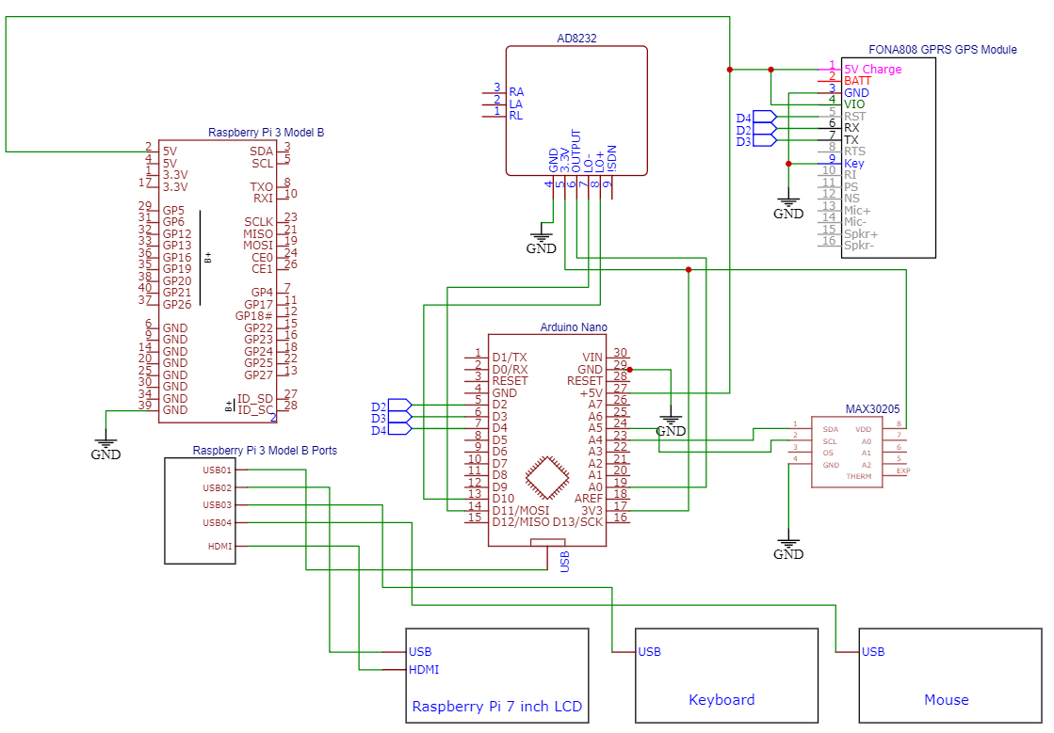

Yung algorithm ng ECG based lang sa number of inspiration and experiation using yung highest peak saka lowest peak.

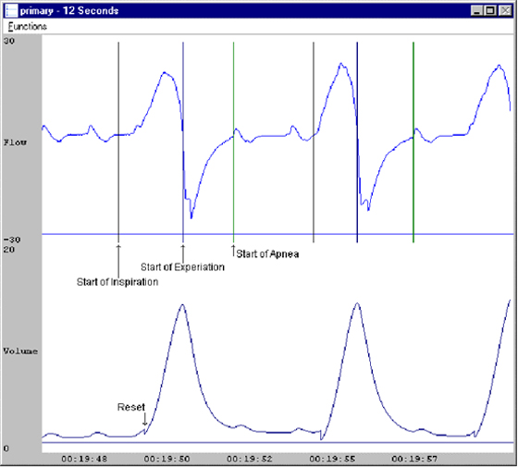

Yung isang letter “S” na nakahiga tas may buntot, isang hinga yun. Every 30 seconds minemeasure yan, and mumultiply by 2 para makuha yung respiration rate.

Yung may count count ng peak na sinasabi ni Dennis is pang unfiltered signal na algorithm yun. Yung sa sensor is expected na filtered na yung data nun.